

**Polling District and Polling Place Review 2025**

**Denton and Westerhope Ward**

**Parliamentary Constituency:** Central and West

**(Proposed) Polling Districts:** H01, H02, H03, H04

The Local Government Boundary Commission for England are an independent body accountable to Parliament. They are responsible for reviewing councils to make sure their patterns of internal wards are fair and sensible. Their reviews include at least two rounds of public consultation before they make recommendations for change.

The final recommendations were published on 7 January 2025, and the new arrangements apply to local elections from 2026.

As a result of changes to ward boundaries the Acting Returning Officer (ARO) is conducting a review of polling districts and polling places to ensure that they are suitable for the new ward boundaries.

For more information on the local government boundary review visit: <https://www.lgbce.org.uk/all-reviews/newcastle-upon-tyne>

This document provides details of the review, along with the initial recommendations and comments of the Acting Returning Officer (ARO). Also, the election rules require the ARO to decide how many polling stations are required for each polling station and the ARO must allocate electors to the polling stations in such manner as they think most convenient.

These recommendations will be open to all residents, stakeholders, and any interested parties. We shall be seeking representations from local disability groups on the accessibility and suitability of polling places. Any comments should be addressed in the first instance to pollingplaces@newcastle.gov.uk where they will be collated on behalf of the (Acting) Returning Officer.

We considered the following factors:

* **Identifying new polling places:** We will look for new polling places in areas where the existing provision is unsuitable or unavailable.
* **Feedback:** We will consider feedback received following recent elections, consultation from members of the public, elected members, and other stakeholders.
* **Accessibility:** We will try to ensure that every polling place is accessible to electors with disabilities.
* **Facilities**: We will make sure that all electors have such reasonable facilities for voting as are practicable in the circumstances.
* **Elector numbers:** We will try to comply with the Electoral Commission guidance on the maximum number of electors that should be allocated to a polling station which should not exceed 2,250.
* **Future housing developments**: We will consider the impact of proposed housing developments on polling station electorates.

**(Current) Denton and Westerhope Ward**

This map shows the current ward and polling district boundaries and the polling places.

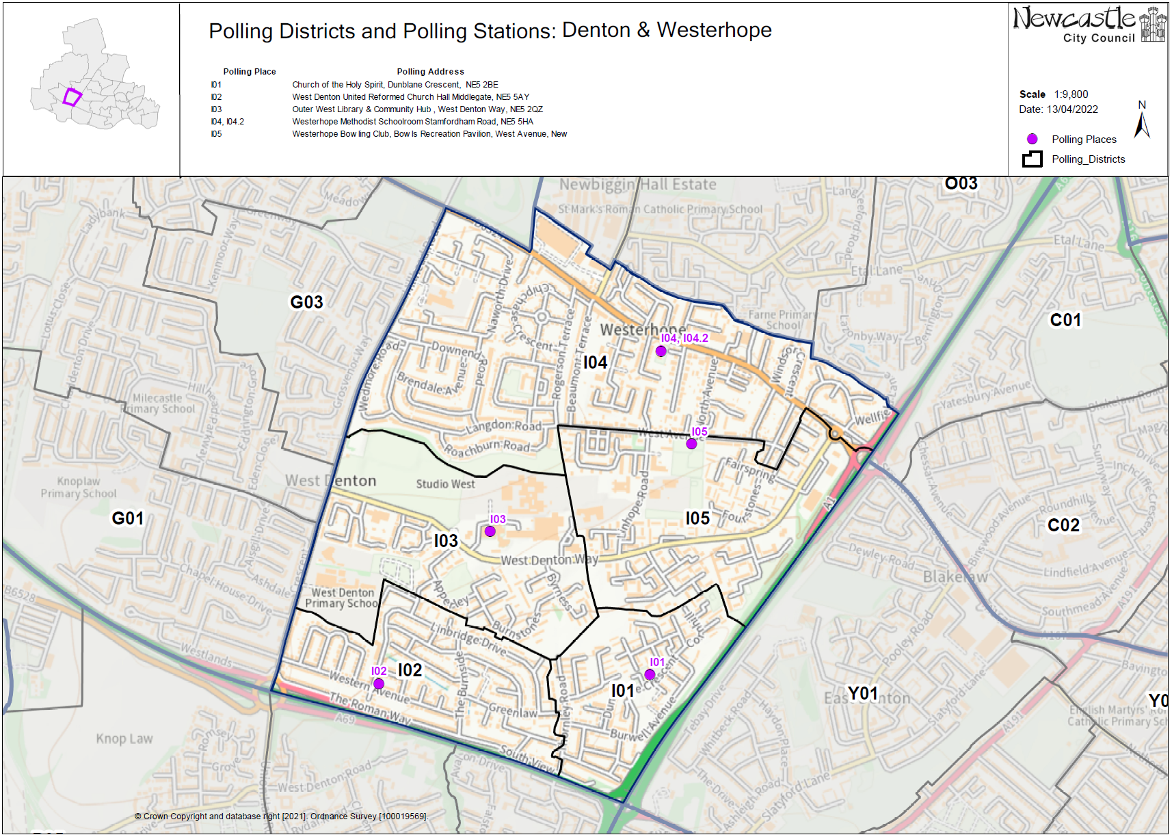

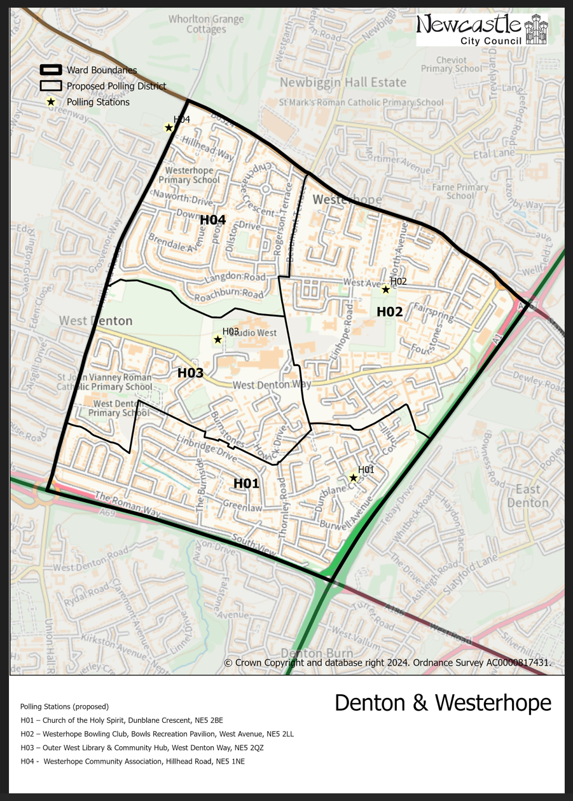**(New)**

**Denton and Westerhope Ward**

This map shows the new ward and the proposed polling districts and the proposed polling places.

* H01 – Church of the Holy Spirit, Dunblane Crescent, NE5 2BE
* H02 – Westerhope Bowling Club, Bowls Recreation Pavilion, West Avenue, NE5 2LL
* H03 – Outer West Library & Community Hub, West Denton Way, NE5 2QZ
* H04 – Westerhope Community Association, Hillhead Road, NE5 1NE

**Denton and Westerhope Ward**

**Polling District H01**

|  |  |
| --- | --- |
| **Current Polling District** | **Current Polling Place** |
| I01 (full)  I02 (full) | Church of the Holy Spirit, Dunblane Crescent, NE5 2BE  West Denton United Reformed Church, Middlegate, NE5 5AY |

|  |  |  |
| --- | --- | --- |
| **Proposed Polling District** | **Predicted**  **Polling Station Electorate** | **Proposed Polling Place** |
| H01 | 1673 | Church of the Holy Spirit, Dunblane Crescent, NE5 2BE |

|  |
| --- |
| **Considerations and Proposals** |
| Merge current I01 and I02 to create the proposed H01 district. These two districts previously contained a low number of electors, so it is proposed to merge them.  Both stations are within the proposed H01 district so both could be considered, however the proposal is to use Church of the Holy Spirit. |

|  |
| --- |
| **Preliminary Consultation – Elected Members comments and feedback** |
| No comments received. |

**Denton and Westerhope Ward**

**Polling District H02**

|  |  |
| --- | --- |
| **Current Polling District** | **Current Polling Place** |
| I04 (part of)  I05 (full) | Westerhope Methodist Church, Stamfordham Road, NE5 5HA  Westerhope Bowling Club, Bowls Recreation Pavilion, West Avenue, NE5 2LL |

|  |  |  |
| --- | --- | --- |
| **Proposed Polling District** | **Predicted**  **Polling Station Electorate** | **Proposed Polling Place** |
| H02 | 1666 | Westerhope Bowling Club, Bowls Recreation Pavilion, West Avenue, NE5 2LL |

|  |
| --- |
| **Considerations and Proposals** |
| Merge current I05 and part of I04 to create the proposed H02. Properties to the east of Beaumont Terrace now move into the proposed H02 district.  Both stations are within the proposed H02 district so both could be considered, however Westerhope Bowling Club is the proposed station. |

|  |
| --- |
| **Preliminary Consultation – Elected Members comments and feedback** |
| No comments received. |

**Denton and Westerhope Ward**

**Polling District H03**

|  |  |
| --- | --- |
| **Current Polling District** | **Current Polling Place** |
| I03 (full) | Outer West Library & Community Hub, West Denton Way, NE5 2QZ |

|  |  |  |
| --- | --- | --- |
| **Proposed Polling District** | **Predicted**  **Polling Station Electorate** | **Proposed Polling Place** |
| H03 | 628 | Outer West Library & Community Hub, West Denton Way, NE5 2QZ |

|  |
| --- |
| **Considerations and Proposals** |
| Current I03 is now the proposed H03. No change to the polling district boundary.  No change to the polling place. |

|  |
| --- |
| **Preliminary Consultation – Elected Members comments and feedback** |
| No comments received. |

**Denton and Westerhope Ward**

**Polling District H04**

|  |  |
| --- | --- |
| **Current Polling District** | **Current Polling Place** |
| I04 (part of) | Westerhope Methodist Church, Stamfordham Road, NE5 5HA |

|  |  |  |
| --- | --- | --- |
| **Proposed Polling District** | **Predicted**  **Polling Station Electorate** | **Proposed Polling Place** |
| H04 | 1043 | Westerhope Community Association, Hillhead Road, NE5 1NE |

|  |
| --- |
| **Considerations and Proposals** |
| Part of the current I04 district is now the proposed H04 district. Properties to the west of Beaumont Terrace now move into the proposed H04 district.  Westerhope Primary was considered; however, it was deemed that this building would not be a viable option to use as a polling station.  The suggestion is to use Westerhope Community Association, which is in Chapel ward, but better situated for electors in the proposed H04 district.  Westerhope Community Association is suggested as a double polling station for the proposed districts of F03 and H04. |

|  |
| --- |
| **Preliminary Consultation – Elected Members comments and feedback** |
| Councillor Marc Donnelly would like Westerhope Community Association to be used as a double station. |